Section I: Scenario Demographics

Scenario Title: | Status Epilepticus
Date of Development: | 29/02/2016 (DD/MM/YYYY)
Target Learning Group: | Juniors (PGY 1 – 2) Seniors (PGY ≥ 3) All Groups

Section II: Scenario Developers

Scenario Developer(s): | Donika Orlich (Adapted from Hyponatremic Seizure case by Kyla Caners)
Affiliations/Institution(s): | McMaster University
Contact E-mail (optional): | Donika.orlich@medportal.ca

Section III: Curriculum Integration

Learning Goals & Objectives
Educational Goal: | To expose learners to a patient with refractory status epilepticus.
CRM Objectives: | - Demonstrate clear communication with team members, defining order of tasks and listening to team input  - Demonstrates problem solving by displaying an organized and efficient approach to the clinical scenario along with concurrent management  - Demonstrates appropriate debriefing in the context of medication error
Medical Objectives: | - Considers a broad DDx of status epilepticus and initiates appropriate work-up and initial management  - Employs appropriate medical therapy for refractory status including consideration of antidotes for rare, yet reversible, causes  - Initiates appropriate post-intubation care including imaging, ICU consult and continuous EEG monitoring

Case Summary: Brief Summary of Case Progression and Major Events
38F presents actively seizing with EMS. She will fail to respond to repeat doses of IV benzo’s, and will require escalating medial management. Following Dilantin infusion, the patient will become hypotensive (because the Dilantin was given as a “push dose”, which the nurse will mention). The patient will then stop her GTC seizure, but will remain unresponsive with eye deviation. The team should recognize this as subclinical status, and proceed to intubate the patient. The patient will continue to seize following phenobarbital and propofol infusion. Urgent consults to radiology and ICU should be made to expedite care out of the ED. The team will be expected to debrief the Dilantin medication error and disclose the error to the husband.

References
Marx, J. A., Hockberger, R. S., Walls, R. M., & Adams, J. (2013). Rosen's emergency medicine: Concepts and clinical practice. St. Louis: Mosby.

Section IV: Scenario Script

A. Scenario Cast & Realism
Patient: | Computerized Mannequin |  |  |  |  | Realism:  Select most important dimension(s) |  |  | Conceptual
 | Mannequin |  |  |  |  |  |  |  | Physical
 | Standardized Patient |  |  |  |  |  |  |  | Emotional/Experiential
 | Hybrid |  |  |  |  |  |  |  | Other:
 | Task Trainer |  |  |  |  |  |  |  | N/A
Confederates | Brief Description of Role
Husband | Will provide extra information on HPI, ROS, PMx and Meds for patient.
Nurse | Will cue team to seizures and remind them repeatedly that patient is still seizing. Also admits to medication error after 3rddilantin is given “IV push”.
B. Required Monitors
EKG Leads/Wires |  |  | Temperature Probe |  |  |  | Central Venous Line
NIBP Cuff |  |  | Defibrillator Pads |  |  |  | Capnography
Pulse Oximeter |  |  | Arterial Line |  |  |  | Other:
C. Required Equipment
Gloves |  |  | Nasal Prongs |  |  |  | Scalpel
Stethoscope |  |  | Venturi Mask |  |  |  | Tube Thoracostomy Kit
Defibrillator |  |  | Non-Rebreather Mask |  |  |  | Cricothyroidotomy Kit
IV Bags/Lines |  |  | Bag Valve Mask |  |  |  | Thoracotomy Kit
IV Push Medications |  |  | Laryngoscope |  |  |  | Central Line Kit
PO Tabs |  |  | Video Assisted Laryngoscope |  |  |  | Arterial Line Kit
Blood Products |  |  | ET Tubes |  |  |  | Other:
Intraosseous Set-up |  |  | LMA |  |  |  | Other:
D. Moulage
None required.

E. Approximate Timing
Set-Up: |  | 3 min |  | Scenario: | 15 min |  |  | Debriefing: |  | 15 min

Section V: Patient Data and Baseline State

A. Clinical Vignette: To Read Aloud at Beginning of Case
Annie Jones is a 38 F brought in by EMS with active seizure. She was last seen normal about 45 minutes ago by husband, and has been witnessed seizing now for about 20 minutes. She is known to have epilepsy. EMS have 1 line in place, and have given 5mg IV midazolam en route.
OTHER HX if EMS Asked:
Vitals: HR 140, BP 130/80, RR 12, O2 99% on NRB, Glucose 6.5
PMHx: Epilepsy, hypothyroid, depression
Meds: List given
ROS: Husband states well prior to today. Has been having more nocturnal seizures since meds changed
B. Patient Profile and History
Patient Name: Annie Jones |  |  |  |  |  | Age: 38 |  |  |  |  |  |  |  | Weight: 50kg
Gender: M F |  |  |  |  |  | Code Status: Full
Chief Complaint: Seizure
History of Presenting Illness: Seizure meds changed 1 month ago. Since then, her nocturnal seizures have been more frequent. Today husband found her seizing and she hasn’t stopped since.
Past Medical History: |  | Epilepsy |  |  |  |  | Medications: |  |  |  |  | Topiramate 200 BID
 |  | Hypothyroidism |  |  |  |  |  |  |  |  |  | Vimpat 100 BID
 |  | Depression |  |  |  |  |  |  |  |  |  | Levothyroxine 125mcg daily
 |  |  |  |  |  |  |  |  |  |  |  | Celexa 20mg daily
Allergies: Sulfa
Social History: Lives with husband. Non-smoker. No EtOH.
Review of Systems: |  | CNS: |  |  | Nocturnal seizures for 1/12 since meds changed.
 |  | HEENT: |  |  | Nil. No recent HI/trauma
 |  | CVS: |  |  | No CP, no palpitations.
 |  | RESP: |  |  | No SOB.
 |  | GI: |  |  | Nil
 |  | GU: |  |  | No UTI symptoms.
 |  | MSK: |  |  | Nil |  |  |  |  |  |  |  | INT: |  | No fevers
C. Baseline Simulator State and Physical Exam
No Monitor Display |  |  |  | Monitor On, no data displayed |  |  |  |  |  |  | Monitor on Standard Display
HR: 130/min |  |  | BP: 130/80 |  |  |  |  | RR: 12/min |  |  |  |  |  |  | O₂SAT: 96% NRB
Rhythm: NSR |  |  | T: 36.4ºC |  |  |  |  | Glucose: 6.4 mmol/L |  |  |  |  |  |  | GCS: 3 (seizing only)
General Status: Ongoing seizure.
CNS: | Ongoing seizure.
HEENT: | No signs HI. Pupils 3mm, non-reactive.
CVS: | No murmur.
RESP: | GAEB, no advent.
ABDO: | Soft, NT.
GU: | Nil.
MSK: | No signs trauma. |  |  |  |  |  |  |  | SKIN: | Nil.

Scenario States, Modifiers and Triggers
Patient State | Patient Status | Learner Actions, Modifiers & Triggers to Move to Next State
1. Seizure  Rhythm: NSR  HR: 130/min  BP: 130/80  RR: 12/min  O₂SAT: 96% NRB  T: 36.4ºC | Generalized tonic clonic seizure. | Learner Actions  - IV access, monitors, bolus  - LLD position, suctioning  - Cap sugar: 6.4  - Blood work: tox, lytes, extended lytes, TSH, ASA, Tylenol  - Urine BHCG  - Administer benzo x2 doses  - Obtain collateral hx from husband | Modifiers  Changes to patient condition based on learner action  - 1L NS BP 140/80  - 2 doses benzos no change  Triggers  For progression to next state  - 4 min or 2 doses benzo 2. Benzo-Refractory Seizure
2. Benzo-Refractory Seizure  HR 140  BP 155/95  O₂SAT 94% | Ongoing GTC seizure. | Learner Actions  - Start 2nd iv line (if not done)  - Start 2nd line agent Phenytoin load (15-20mg/kg or 1g IV over 30 mins)  - Prepare for intubation | Modifiers  - Benzo given ongoing seizure  Triggers  - Dilantin given 3. BP drop  - Intubation 5. Refractory status
3. BP drop  HR 140  BP 80/50  O₂SAT slowly decrease to 90% | Nurse asks whether BP drop could be due to “push dose Dilantin”? | Learner Actions  - Start 2nd iv line (if not done)  - IV NS bolus | Modifiers  - IV NS 1L bolus BP 90/60  Triggers  - 6 min or NS bolus given 4. Subclinical Status
4. Subclinical Status  HR 140  BP 100/70  O₂SAT 90% | GTC seizure stops. Eye deviation to L. Pupils non reactive. Mouth twitching. | Learner Actions  - Intubation (propofol + paralytic)  - Start 3rd line agent -> Phenobarb (15-20mg/kg)  - Request continuous EEG monitor from ICU  - ECG | Modifiers  - No agent will stop seizure (no pupillary response if intubated)  Triggers  - Intubation 5. Refractory Status
5. Refractory Status  HR 139  BP 120/85  O2 99% (vented)  RR 12 (vented) | Intubated. No pupillary response. | Learner Actions  - Give 2nd and 3rd line agents (if not yet done)  - Consider empirics (pyridoxine + 3% NS + MgSO4 if pregnancy a consideration)  - Consider antibiotics, antivirals  - Propofol infusion  - ICU consult and Neuro consult  - Anesthesia consult (for inhalational anesthesia)  - Arrange for CT Head  - Debrief team re: med error  - Disclose error to husband | Modifiers  - No agents will stop seizure  Triggers  - Empirics + propofol infusion or 15 minutes END CASE
Section VI: Scenario Progression

Section VII: Supporting Documents, Laboratory Results, & Multimedia

Laboratory Results
None

Images (ECGs, CXRs, etc.)
Post-Intubation CXR  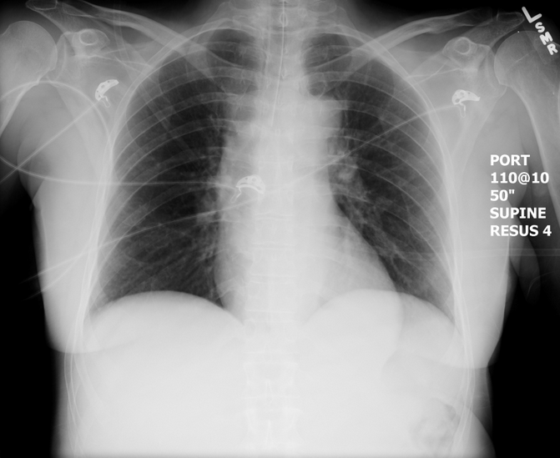  (CXR source: https://emcow.files.wordpress.com/2012/11/normal-intubation2.jpg) | ECG showing NSR  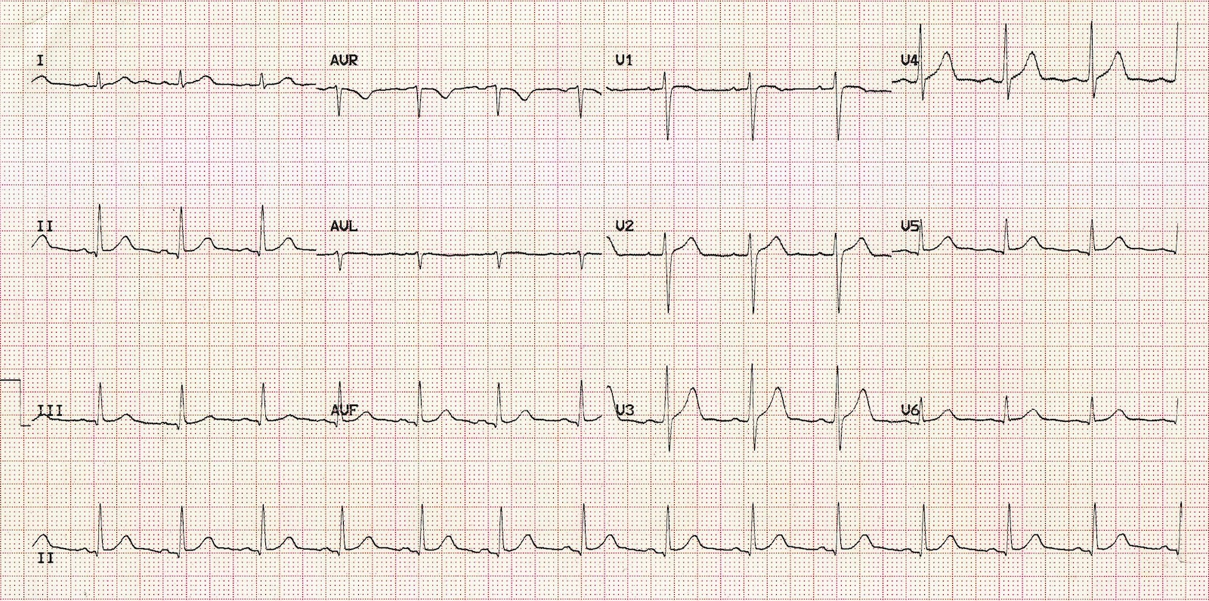  (ECG source: http://i0.wp.com/lifeinthefastlane.com/wp-content/uploads/2011/12/normal-sinus-rhythm.jpg)

Section VIII: Debriefing Guide

General Debriefing Plan
Individual | Group |  | With Video | Without Video
Objectives
Educational Goal: |  | To expose learners to a patient with refractory status epilepticus.
CRM Objectives: |  | - Demonstrate clear communication with team members, defining order of tasks and listening to team input  - Demonstrates problem solving by displaying an organized and efficient approach to the clinical scenario along with concurrent management  - Demonstrates appropriate debriefing in the context of medication error
Medical Objectives: |  | - Considers a broad DDx of status epilepticus and initiates appropriate work-up and initial management  - Employs appropriate medical therapy for refractory status including consideration of antidotes for rare, yet reversible, causes  - Initiates appropriate post-intubation care including imaging, ICU consult and continuous EEG monitoring
Sample Questions for Debriefing
- What was your initial DDx for this patient presenting with seizure?
- Explain your choice of intubation drugs? Is there any benefit to succ over roc in the seizing patient?
- When did you realize that the patient might still be seizing despite lack of general tonic-clonic seizure movement? What are indications for continuous EEG monitoring?
- When should empirics be given to the seizing patient? What do “empirics” include?
- What causes the drop in BP when phenytoin is given too quickly?
Key Moments
- Initial Broad work-up for likely status epilepticus
- Management of refractory status epilepticus
- Acknowledgement of medication error leading to debrief of team afterwards and recognition of need to disclose error to husband

